Jacob Richman
CSD-340
Module 3
Due 11/02/26
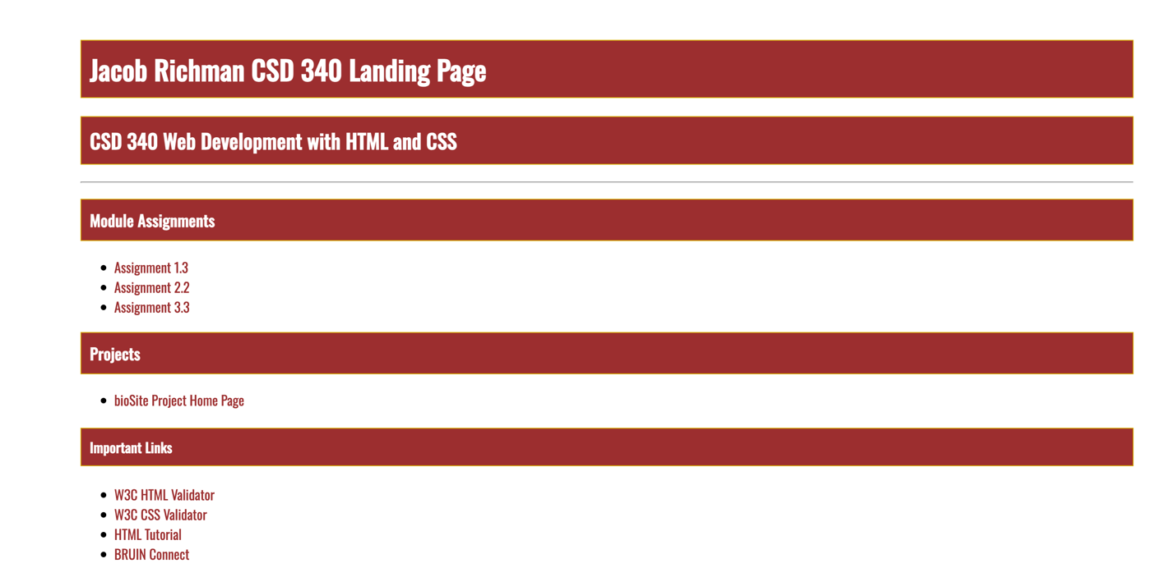
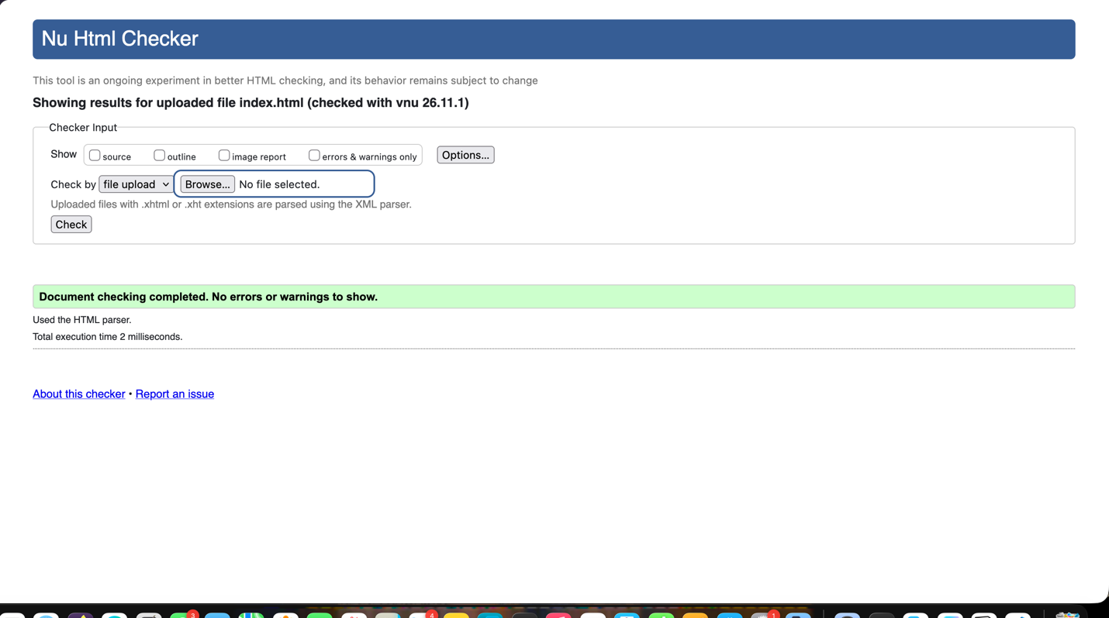
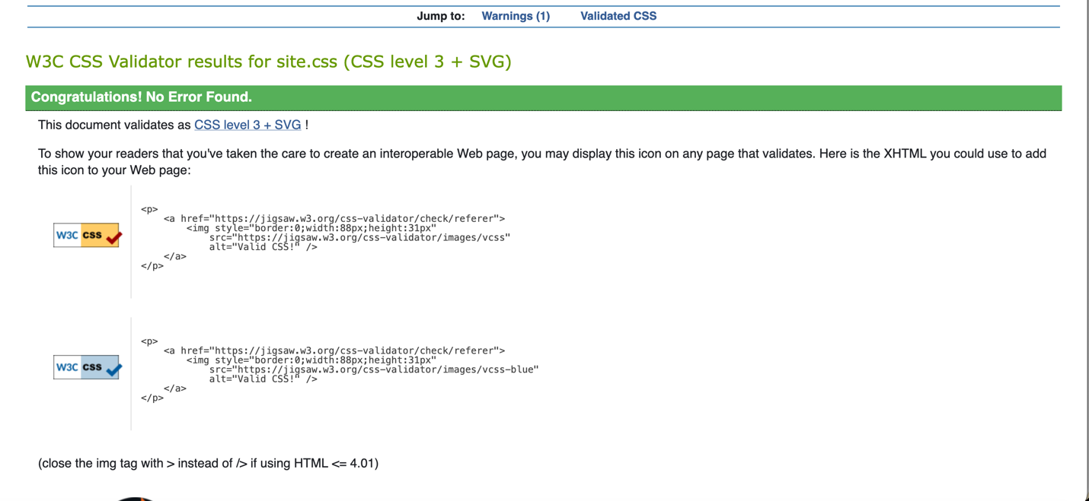


Links: https://github.com/Guitarjake15/csd-340
https://guitarjake15.github.io/csd-340/

